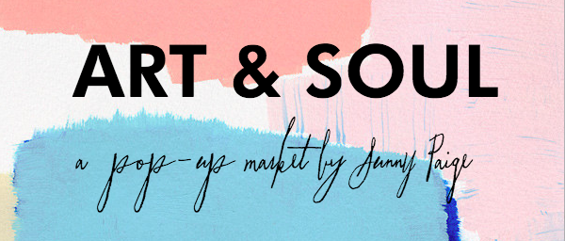
Art & Soul, a pop-up market by Sunny Paige, LLC partnering with Boho Saint Jo, LLC is a juried show curated to promote small businesses and makers of all sorts.

Applications are juried and selected based on both a good fit for the niche market as well as a good fit for the crowd in which we draw. Applicants will receive confirmation via e-mail within 48 hours. Payment is due within 48 hours of your acceptance or your space will be forfeited. Cancellations will be refunded, minus a $50 cancellation fee, if and only if your space can be filled by an approved vendor. No refund will be given for bad weather.

Vendors are provided with a 10 ft. x 10 ft. space and nothing more. Vendors are required to provide everything else while keeping your booth visually aesthetic/appealing at all times. No damage of any kind will be permitted to the venue. Damages to the venue created by an individual will result in a fine paid at their own expense. Early break down is not permitted. Vendors must remove all trash from space and return the space exactly as it was received.

Each vendor is required to promote the event.

Photos will be taken at events for future advertising, marketing and promotional needs. If you, or your products, wish to not be present in any photos, please notify us immediately.

Sunny Paige, LLC will and Boho Saint Jo, LLC will not be held responsible for any theft or damage to space or personal property. Vendors should make arrangements with their own insurance companies for proper coverage.

By clicking the box on the application, you are agreeing to all terms and conditions. It is the responsibility of the vendor to have full knowledge and abide by both the Guidelines and Terms and Conditions.

